Please type the following URL in the Google Chrome:

chrome://flags/#enable-npapi

The Following screen will be displayed

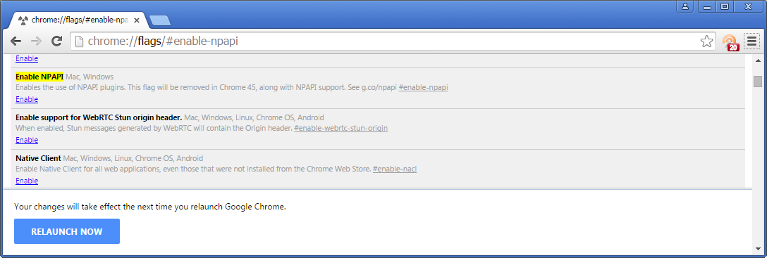

Please observe that “npapi” is highlighted and is asking for Enabling:

Turn on “npapi plugin” by clicking on the Enable button which is highlighted

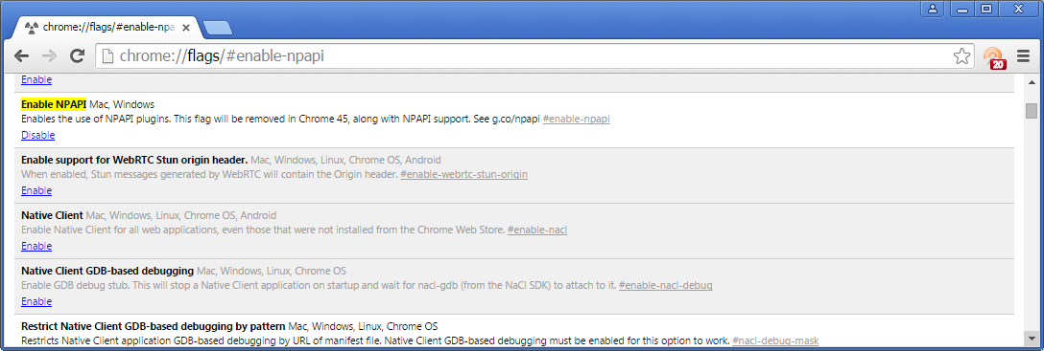

- Close the browser
- Again Launch Google Chrome again

Further open the Google Chrome and type the following URL:

chrome://plugins/

Please observe that the Silverlight plugin is required to be enabled, Please click on the Enable
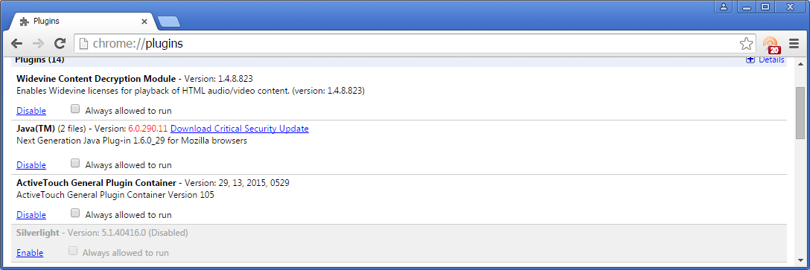

After click of Enable, Please observe the following screen appears

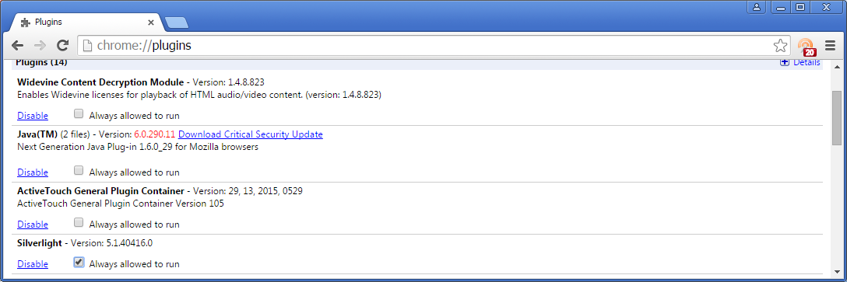

Launch Chrome Again, Silver Light would be operational

