If you are getting error with message “Async Error” please follow below steps.
Set Security level medium to low
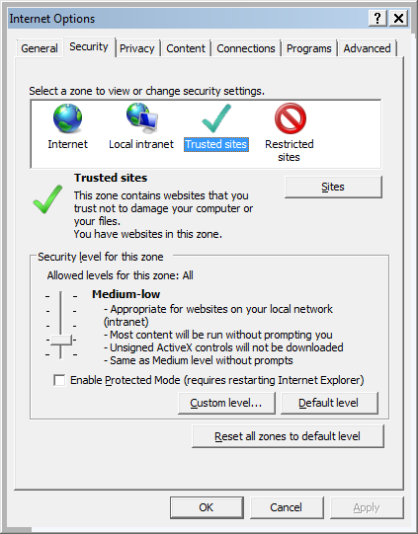
Add the websites in trusted site with https
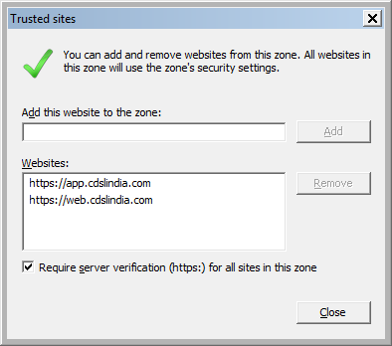
Delete all temporary files .
